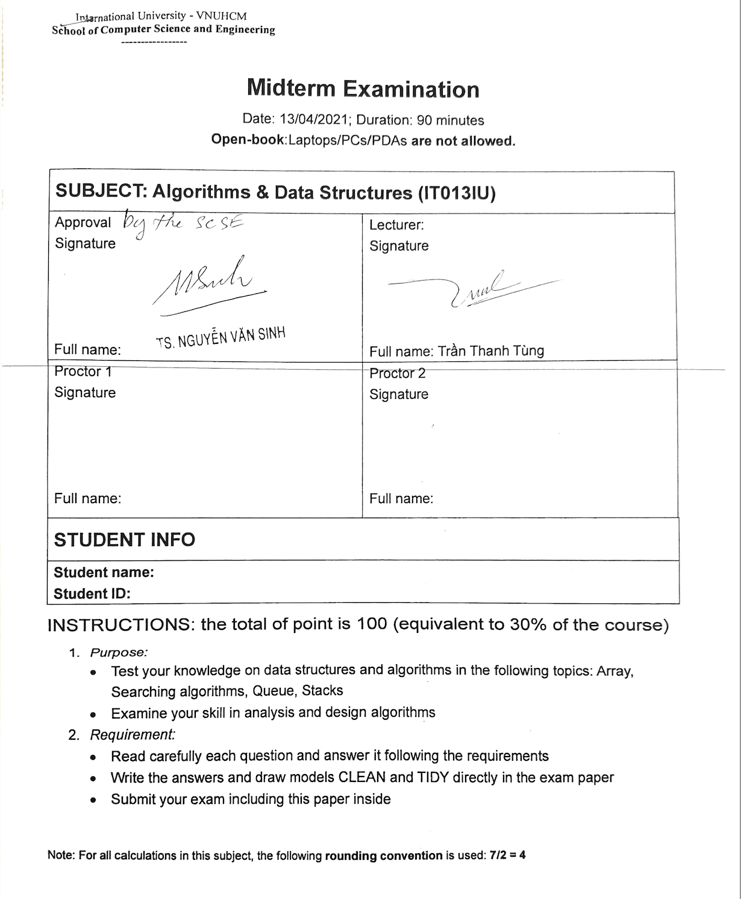

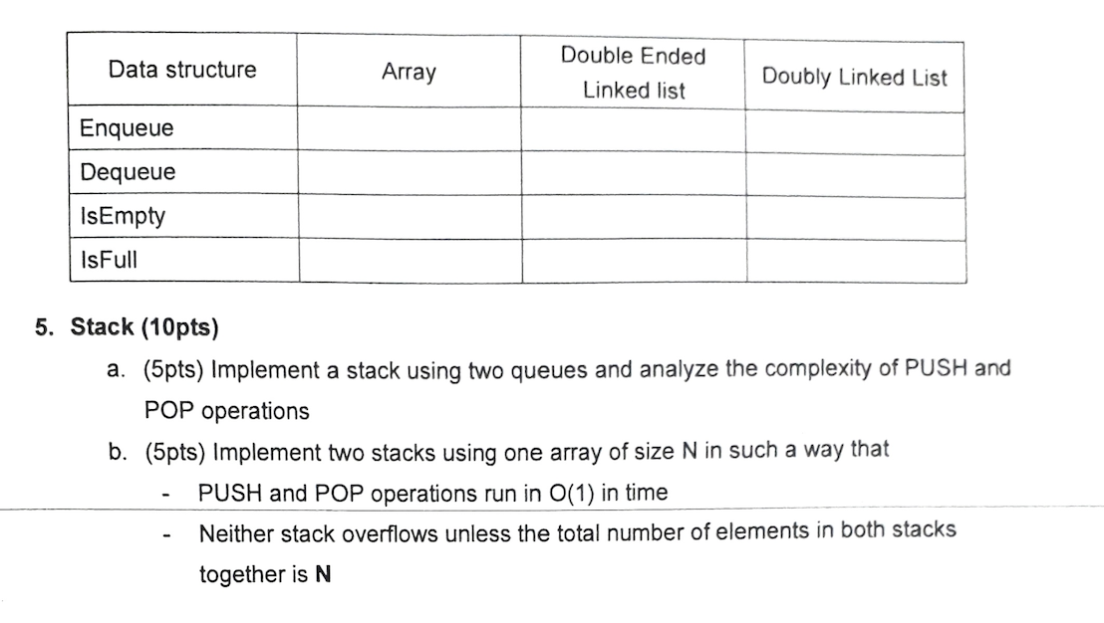

2.

| Action/index | 0 | 1 | 2 | 3 | 4 | 5 | 6 | 7 | 8 | 9 | 10 | 11 | 12 |
| --- | --- | --- | --- | --- | --- | --- | --- | --- | --- | --- | --- | --- | --- |
| Data | 80 | 4 | 3 | 50 | 30 | 1 | 50 | 88 | 2 | 0 | 15 | 43 | 11 |
| swap B[0] to B[6] | 50 | 4 | 3 | 50 | 30 | 1 | 80 | 88 | 2 | 0 | 15 | 43 | 11 |
| swap B[2] to B[8] | 50 | 4 | 2 | 50 | 30 | 1 | 80 | 88 | 3 | 0 | 15 | 43 | 11 |
| swap b[3] to b[9] | 50 | 4 | 2 | 0 | 30 | 1 | 80 | 88 | 3 | 50 | 15 | 43 | 11 |
| swap b[4] to b[10] | 50 | 4 | 2 | 0 | 15 | 1 | 80 | 88 | 3 | 50 | 30 | 43 | 11 |
| swap b[12] to b[0] | 11 | 4 | 2 | 0 | 15 | 1 | 80 | 88 | 3 | 50 | 30 | 43 | 50 |
| swap b[12] to b[6] | 11 | 4 | 2 | 0 | 15 | 1 | 50 | 88 | 3 | 50 | 30 | 43 | 80 |
| swap b[0] to b[3] | 0 | 4 | 2 | 11 | 15 | 1 | 50 | 88 | 3 | 50 | 30 | 43 | 80 |
| swap b[2] to b[5] | 0 | 4 | 1 | 11 | 15 | 2 | 50 | 88 | 3 | 50 | 30 | 43 | 80 |
| swap b[7] to b[10] | 0 | 4 | 1 | 11 | 15 | 2 | 50 | 30 | 3 | 50 | 88 | 43 | 80 |
| swap b[2] to b[1] | 0 | 1 | 2 | 4 | 11 | 15 | 50 | 30 | 3 | 50 | 88 | 43 | 80 |
| swap b[8] to b[3] | 0 | 1 | 2 | 3 | 11 | 15 | 50 | 30 | 4 | 50 | 88 | 43 | 80 |
| swap b[8] to b[4] | 0 | 1 | 2 | 3 | 4 | 15 | 50 | 30 | 11 | 50 | 88 | 43 | 80 |
| swap b[8] to b[5] | 0 | 1 | 2 | 3 | 4 | 11 | 50 | 30 | 15 | 50 | 88 | 43 | 80 |
| swap b[8] to b[6] | 0 | 1 | 2 | 3 | 4 | 11 | 15 | 30 | 50 | 50 | 88 | 43 | 80 |
| swap b[11] to b[8] | 0 | 1 | 2 | 3 | 4 | 11 | 15 | 30 | 43 | 50 | 88 | 50 | 80 |
| swap b[11] to b[10] | 0 | 1 | 2 | 3 | 4 | 11 | 15 | 30 | 43 | 50 | 50 | 88 | 80 |
| swap b[12] to b[11] | 0 | 1 | 2 | 3 | 4 | 11 | 15 | 30 | 43 | 50 | 50 | 80 | 88 |